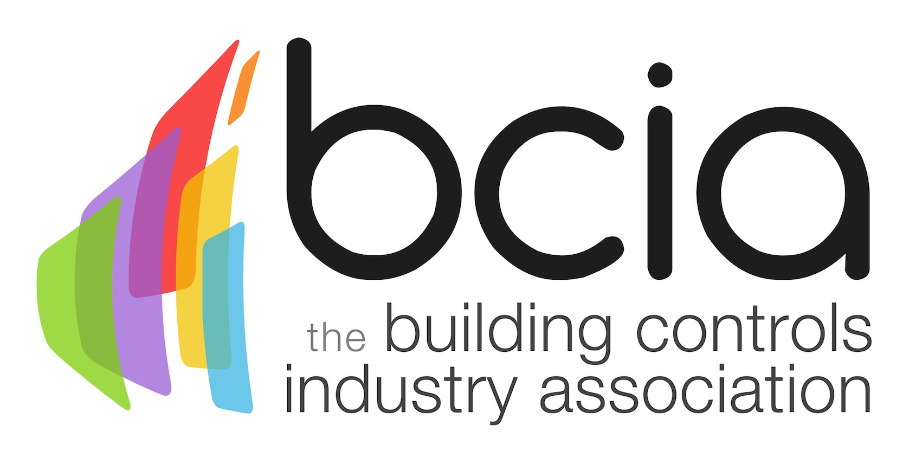

**Press Release**

**20 January 2016**

**Join Rufus Hound at the BCIA Awards 2016**

Engage with global clients at the annual BCIA Awards 2016 and don’t miss a chance to meet Rufus Hound. Book your table now and be part of the biggest event of the year in the building controls industry.

The BCIA Awards 2016 will take place at a brand new venue - the Hilton Birmingham Metropole on Thursday 12 May, where guests will enjoy entertainment provided by the well-known comedian and TV personality, Rufus Hound together with a delicious three-course meal.

The BCIA Awards is a great event that will bring together over 300 building controls manufacturers, system installers, distributors and HVAC providers, giving guests a chance to network and exchange ideas with industry professionals and celebrate their success at this remarkable event.

Not a member? Table bookings are welcome from the BCIA members and non-members.

Ian Ellis, of sponsor Siemens Building Technologies says: “We are delighted to be part of this great event. We have been attending the BCIA Awards for a number of years, and each one of them has been a great experience. This year we have had a fantastic number of entries which is testament to the growing reputation of this event.”

To book a table and for more information, visit: [www.bcia-awards.co.uk](http://www.bcia-awards.co.uk)

[www.bcia.co.uk](http://www.electricalcharity.org)

**Note to editors**

The Building Controls Industry Association (BCIA) represents the UK building controls and BEMS sector. With around 75 members accounting for 70% of the UK controls market, the BCIA is an influential group that promotes better specification, application and use of controls. The BCIA also offers its own training courses and the Building Controls Professional Assessment (BCPA).

For further information about the BCIA please contact Keystone Communications:

Tracey Rushton-Thorpe

Tel: 07753 840386

Email: [tracey@keystonecomms.co.uk](mailto:tracey@keystonecomms.co.uk)